Policy Title | Personal Property Policy
Ratified at School Council | May 2021
To Be Updated on | February 2024
Reviewed by | School Council

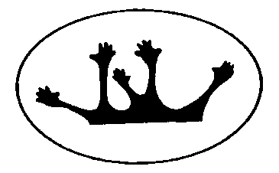

Purpose
To explain Toorloo Arm Primary School’s policy in relation to personal property and to ensure that special or valuable items of personal property are not brought to school.

Scope
This policy applies to all school activities, including camps and excursions.

Policy
Toorloo Arm Primary School understands that staff and/or students may sometimes like to bring items of personal property to school.
The Department of Education and Training does not have insurance for personal property of staff, students and visitors. Toorloo Arm Primary School does not take responsibility for items of personal property that are lost, stolen or damaged at school or during school activities. Damage to personal property brought to school is the responsibility of the owner of that property.
Toorloo Arm Primary School encourages staff and students not to bring items of value to school, or to obtain appropriate insurance for such items.

