|  |  |
| --- | --- |
| Policy last reviewed | June 2024 |
| Approved by | Principal |
| Next scheduled review date | June 2027 |

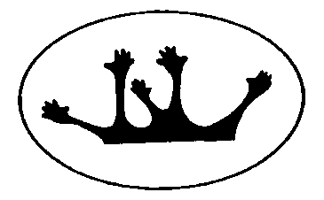

**PERSONAL PROPERTY POLICY**

## **Purpose**

To explain Toorloo Arm Primary’s policy in relation to personal property and to ensure that special or valuable items of personal property are not brought to school.

## **Scope**

This policy applies to all school activities, including camps and excursions.

## **Policy**

Toorloo Arm Primary understands that staff and/or students may sometimes like to bring items of personal property to school.

The Department of Education and Training does not have insurance for personal property of staff, students and visitors. Toorloo Arm Primary does not take responsibility for items of personal property that are lost, stolen or damaged at school or during school activities. Damage to personal property brought to school is the responsibility of the owner of that property.

Toorloo Arm Primary encourages staff and students not to bring items of value to school, or to obtain appropriate insurance for such items.

**COMMUNICATION**

This policy will be communicated to our school community in the following ways:

* Annual reminders in our school newsletter
* Available publicly on our school’s website
* Hard copy available from school administration upon request

## **RELATED POLICIES and resources**

* the Department’s Policy and Advisory Library (PAL):
  + [Claims for Property Damage and Medical Expenses](https://www2.education.vic.gov.au/pal/claims-property-damage-and-medical-expenses/policy)

**POLICY REVIEW AND APPROVAL**

**Help for non-English speakers**

If you need help to understand the information in this policy, please contact the school office.